**Git Basics Assignment 1**

1. **Repository setup**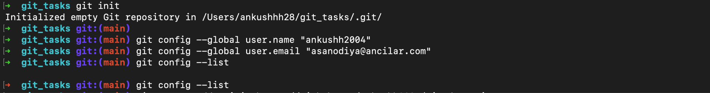

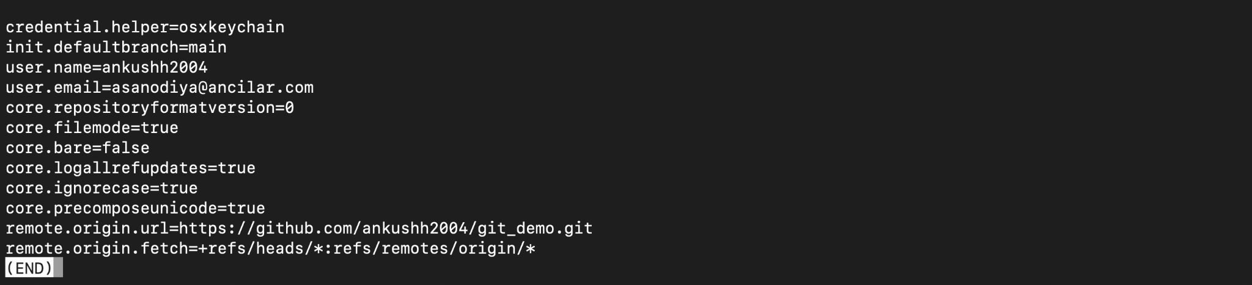

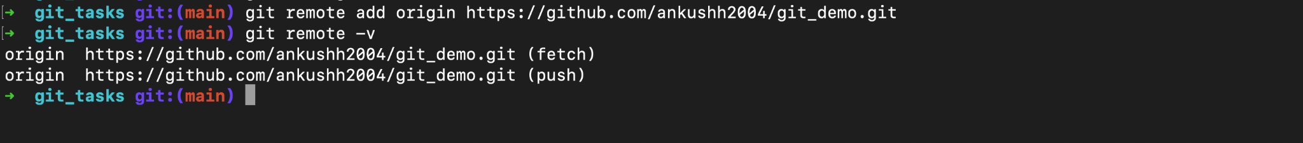

**Query:Why is Git considered one of the most popular version control systems in the industry?**

* Before Git m, version control systems were used by developers to manage their code. They were called SCCS (Source Code Control System).
* SCCS was a proprietary software that was used to manage the history of code.
* It was expensive and not very user-friendly.
* Git was created to replace SCCS and to make version control more accessible and user-friendly as it is open-source and free to all.
* Some common version control systems are Subversion (SVN), CVS, and Perforce.

1. **Working with files and commits**

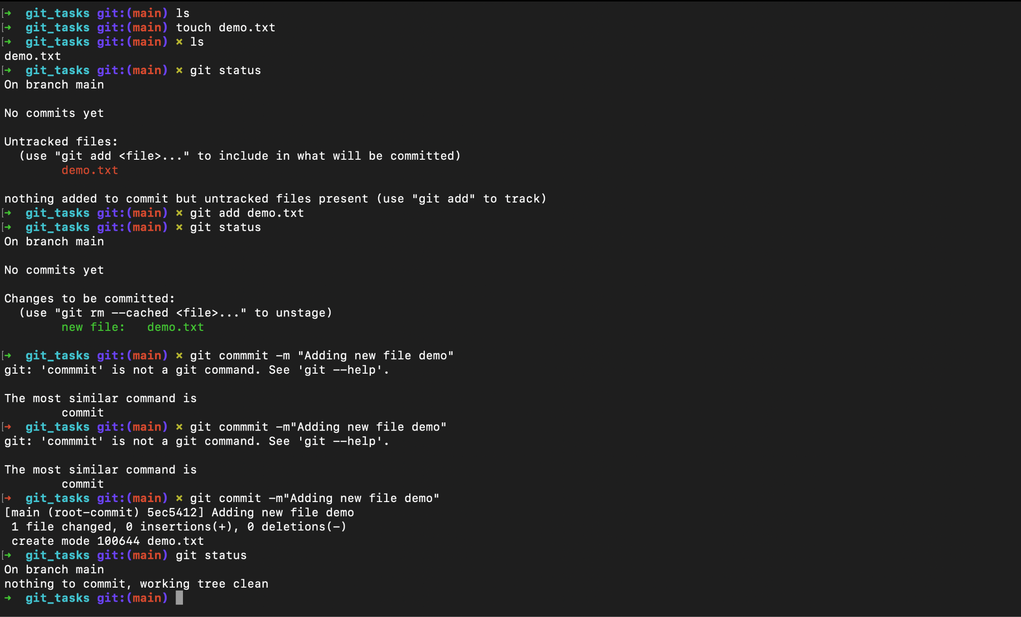

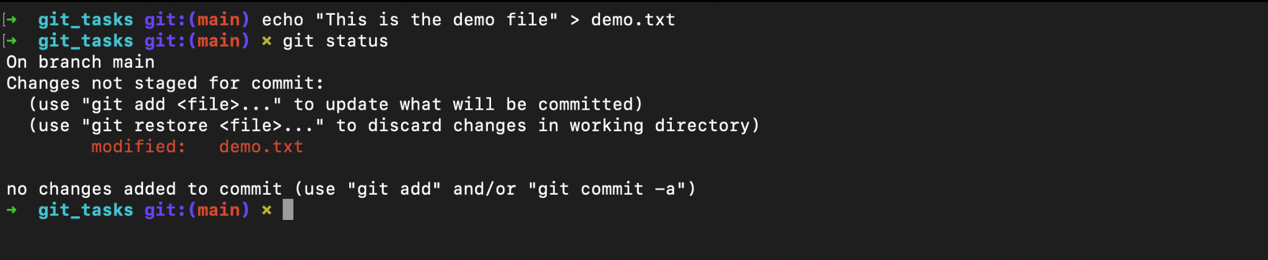

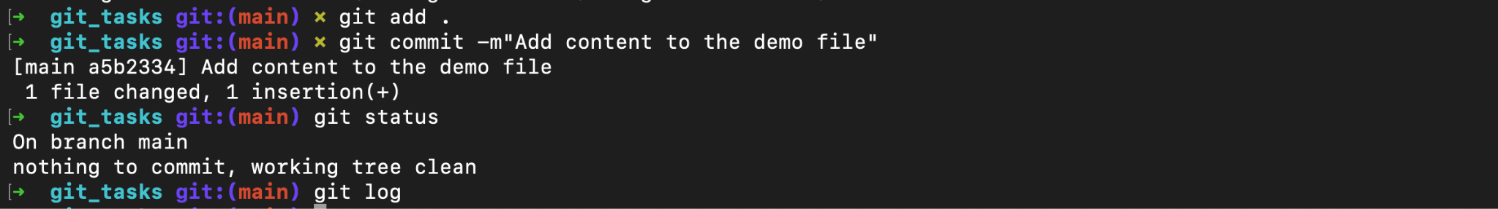

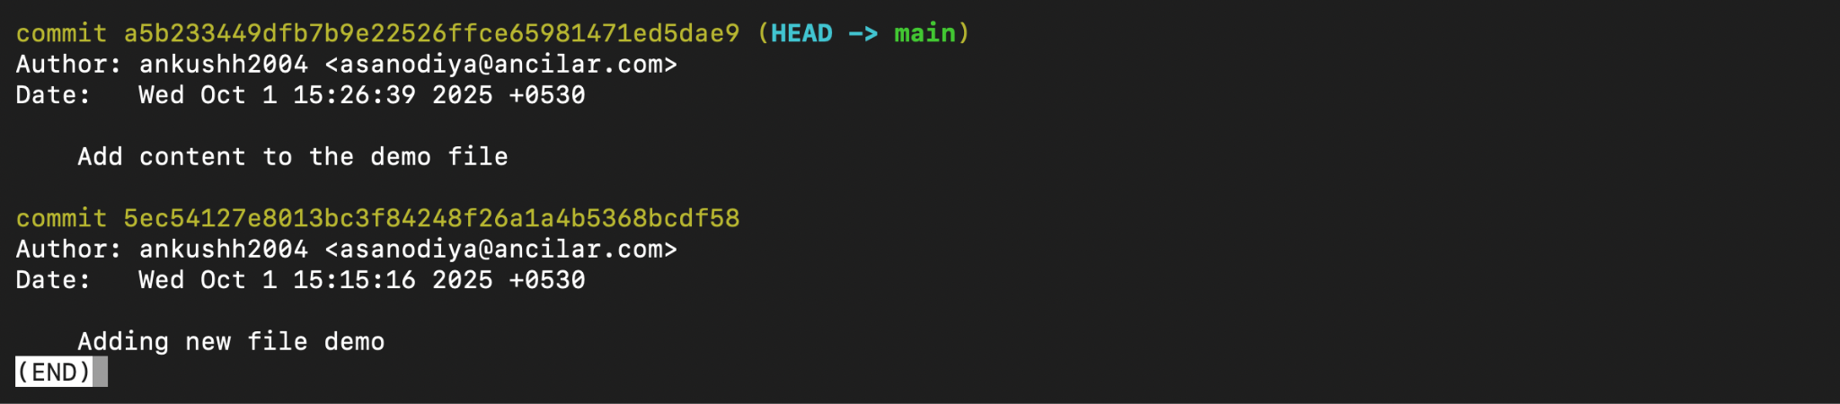







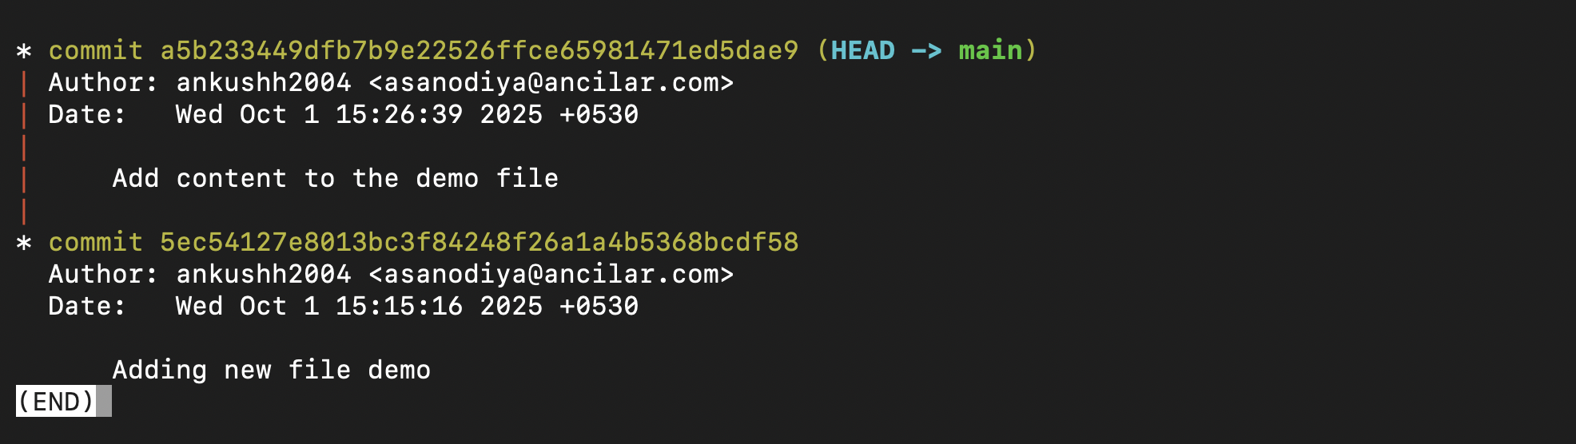

**Query:What is a SHA hash in Git, and why is it important?**

* SHA stands for Secure Hash Algorithm.
* Basically, the SHA algorithm is used for generating a unique commit ID.
* Every commit has a unique hash ID which consists of a 40 characters alpha-numeric unique ID to differentiate commits .

1. **Understanding remote operations**

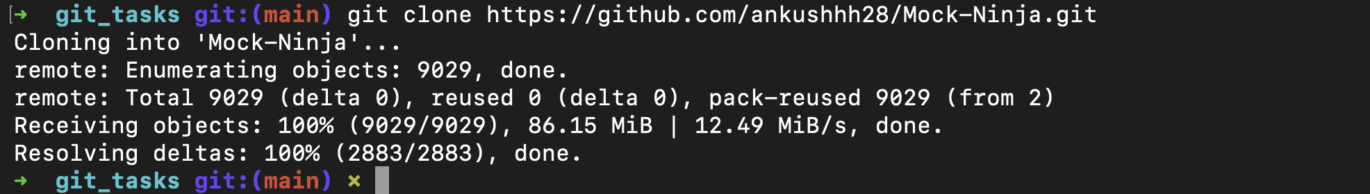

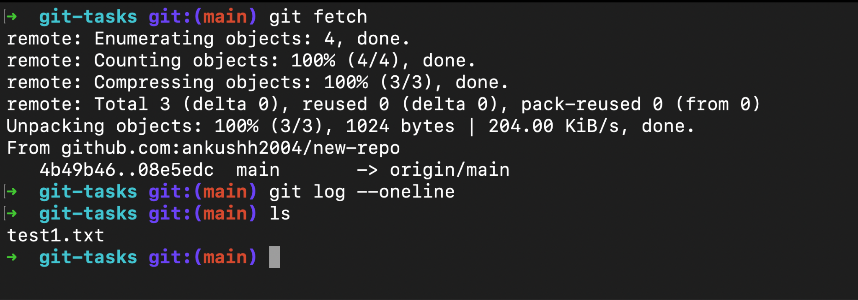

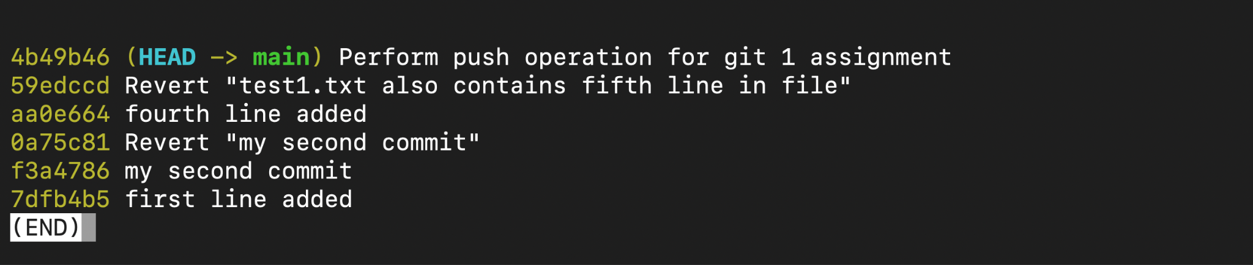

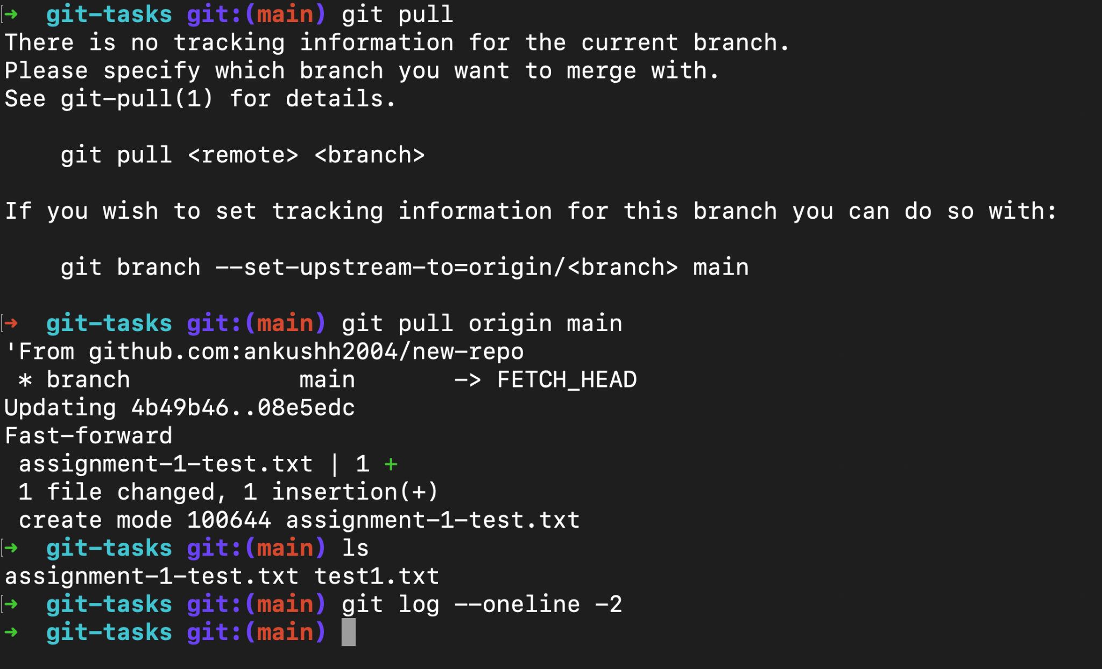

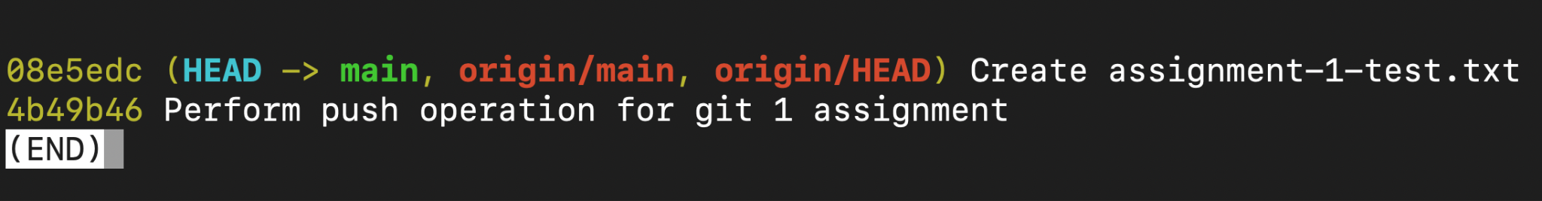

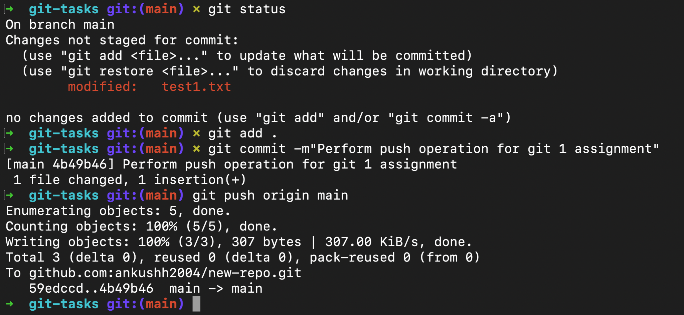

**Query: What is the key difference between git fetch**

**and git pull?**

* **git fetch**

1. Before git fetch, developers had to manually check or pull all changes from a remote repository. The problem was that git pull would automatically merge changes, which could lead to unwanted updates or merge conflicts if you were not ready. To solve this, Git introduced git fetch.
2. git fetch is a command that retrieves updates from a remote repository but does not merge them with your local branch. It is like downloading the latest changes without applying them directly to your working directory.
3. The command fetches all the references (branches, tags, etc.) from the remote, allowing you to review or integrate those updates manually when you are ready.
4. When we run git fetch, Git connects to the remote repository (typically called origin), downloads any new commits or branches, and stores them in your local repository under remote-tracking branches.
5. These remote-tracking branches (like origin/main) represent the latest state of the branches in the remote repository.
6. To save the changes to our local repository or our workspace we need to use the “git fetch” command.

* **git pull**

1. Git pull is a command which is used to fetch and integrate the changes which are present in the remote repository to the local repository.
2. Git pull is basically a combination of git merge and git fetch which is used to update the local branch with the changes available in the remote repository branch.
3. **Commit Lifecycle & modifications**

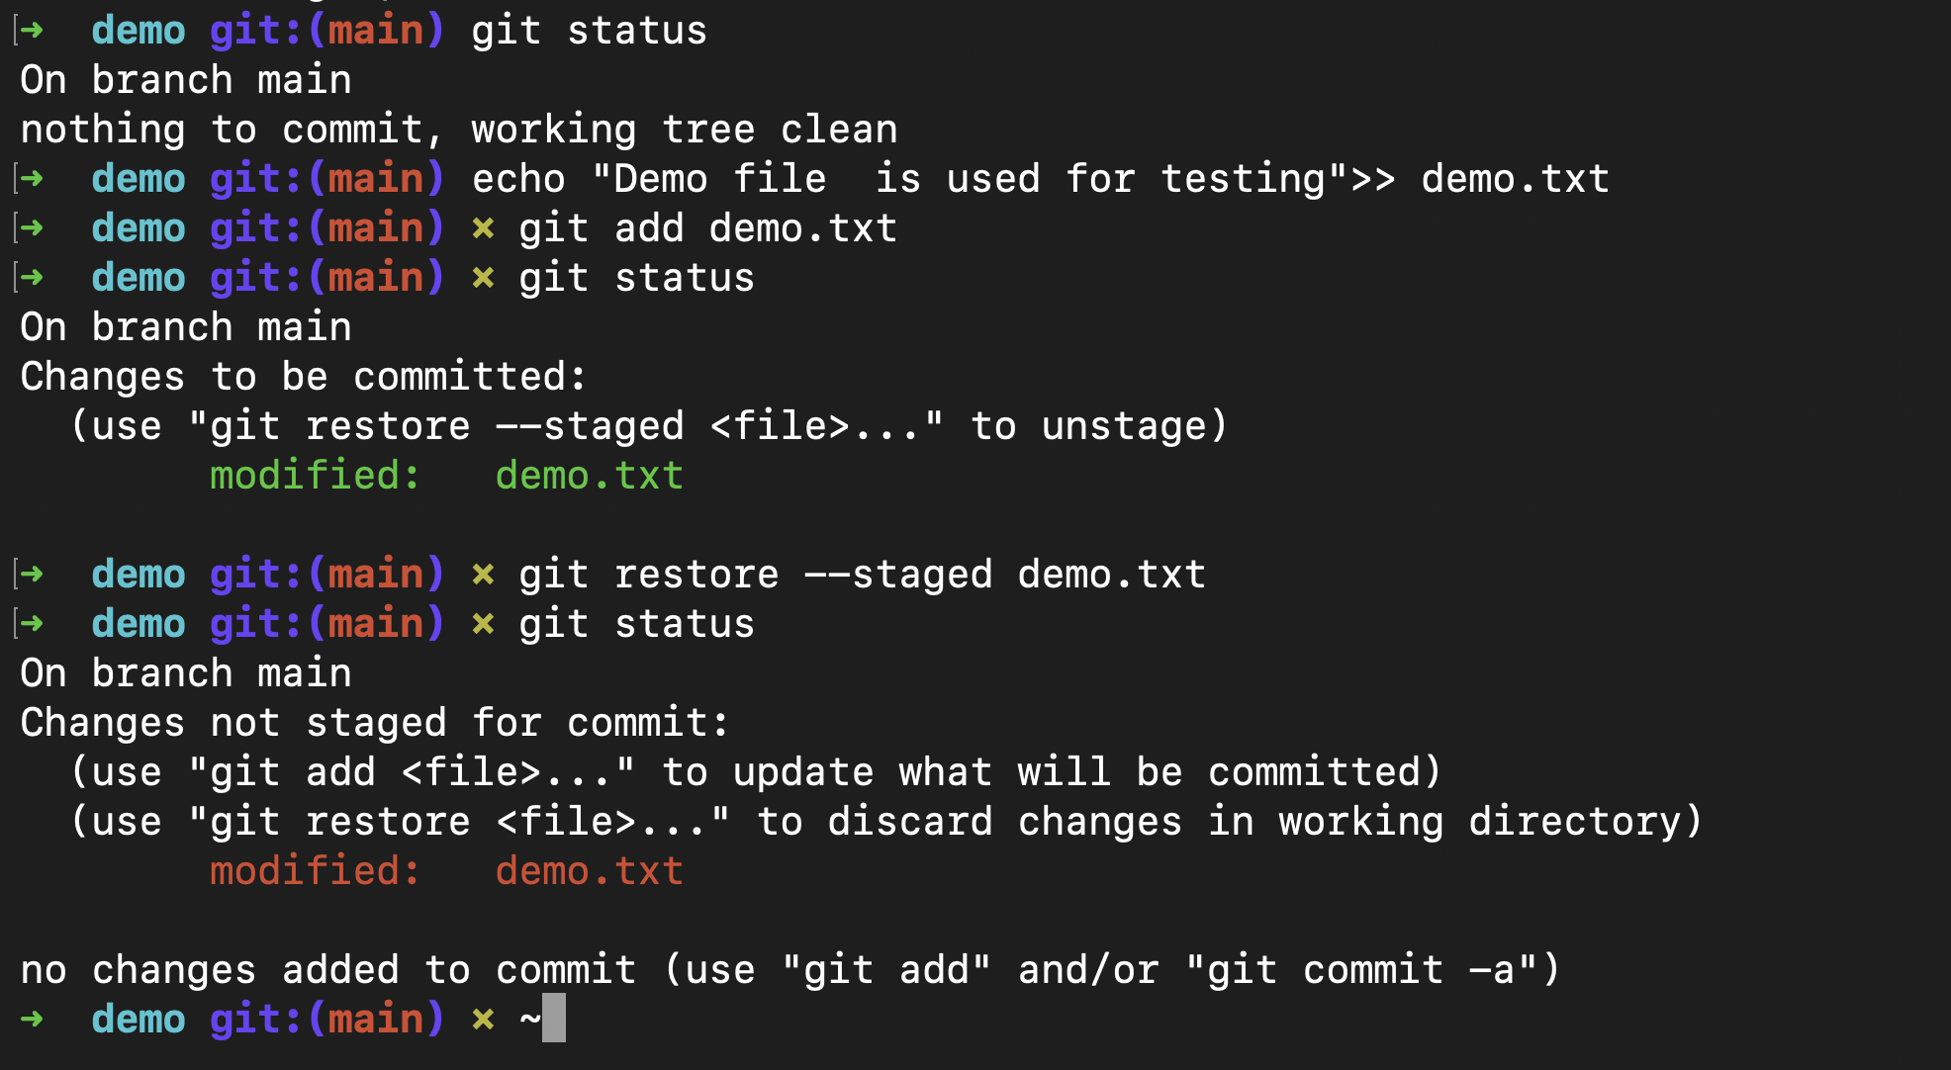

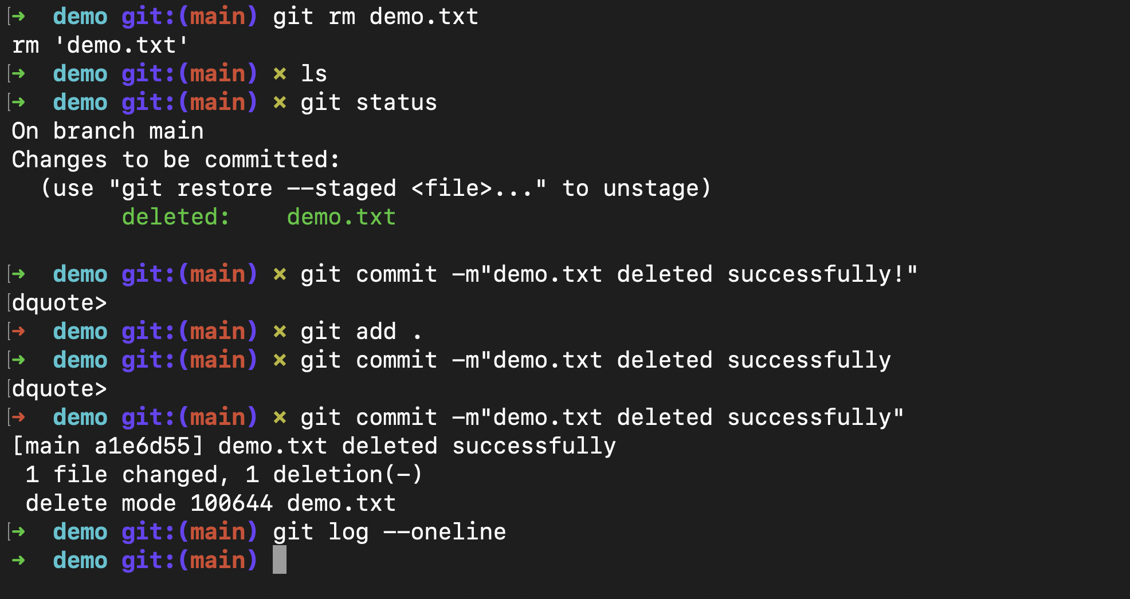

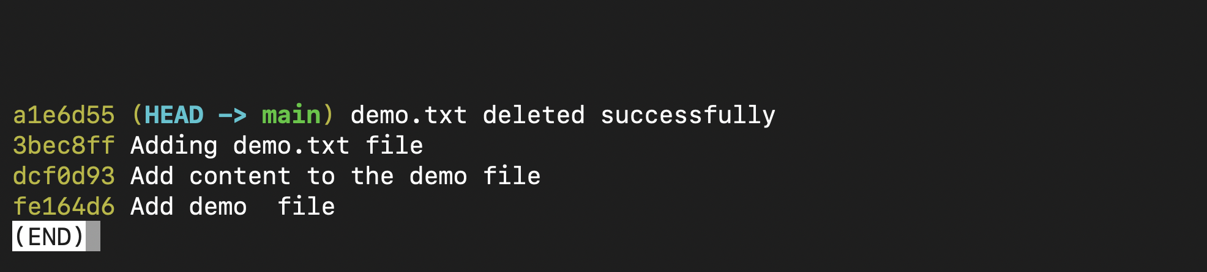

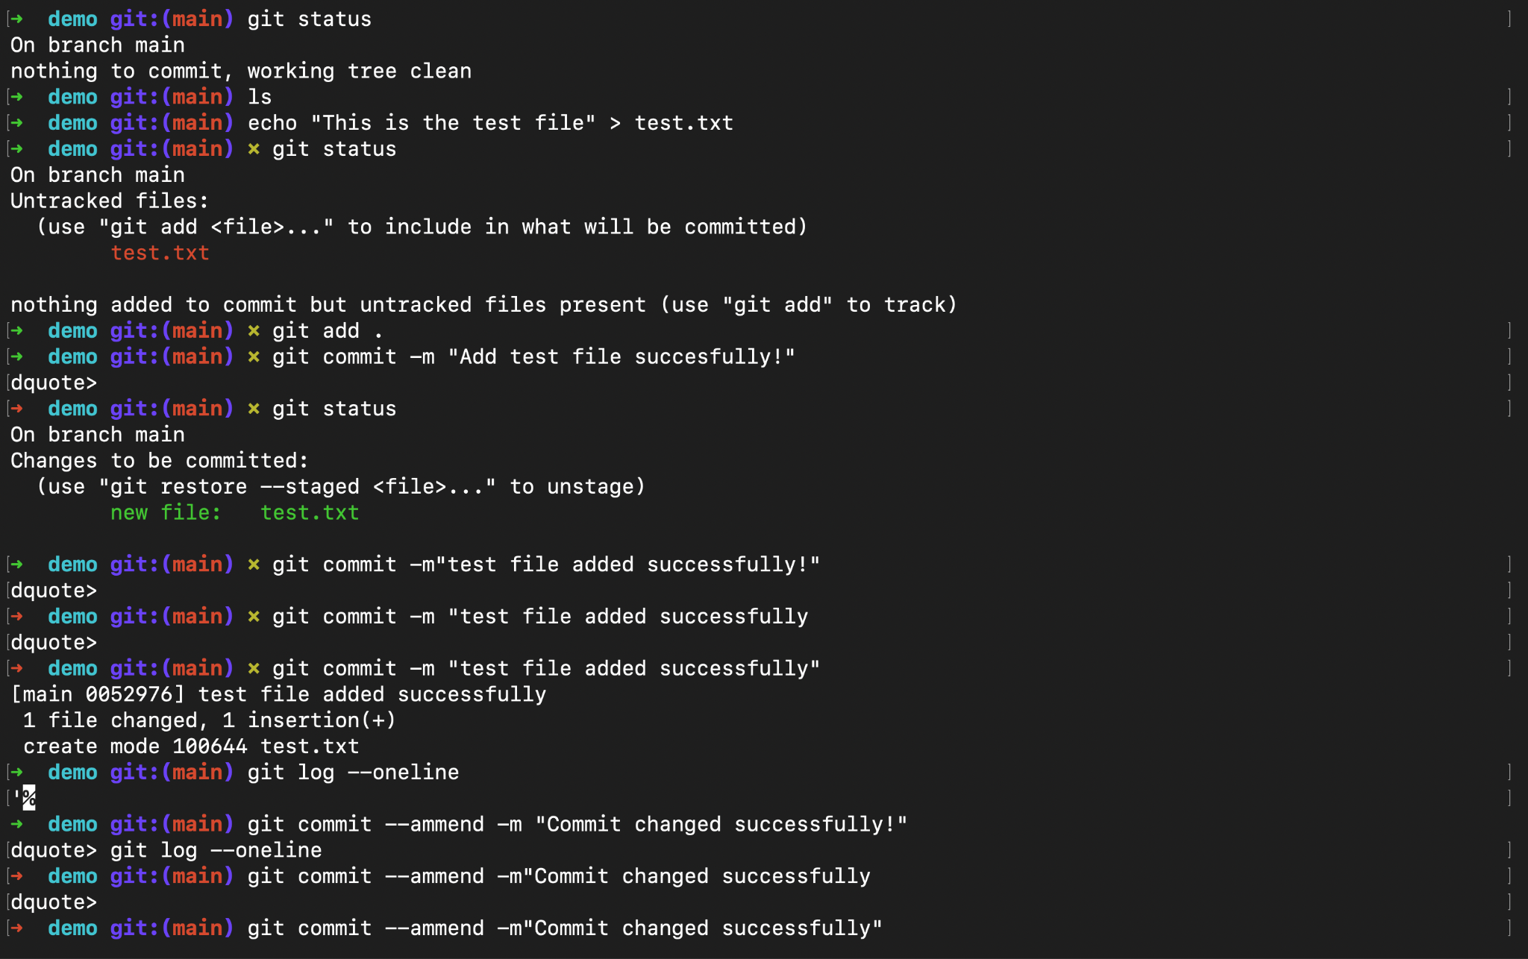

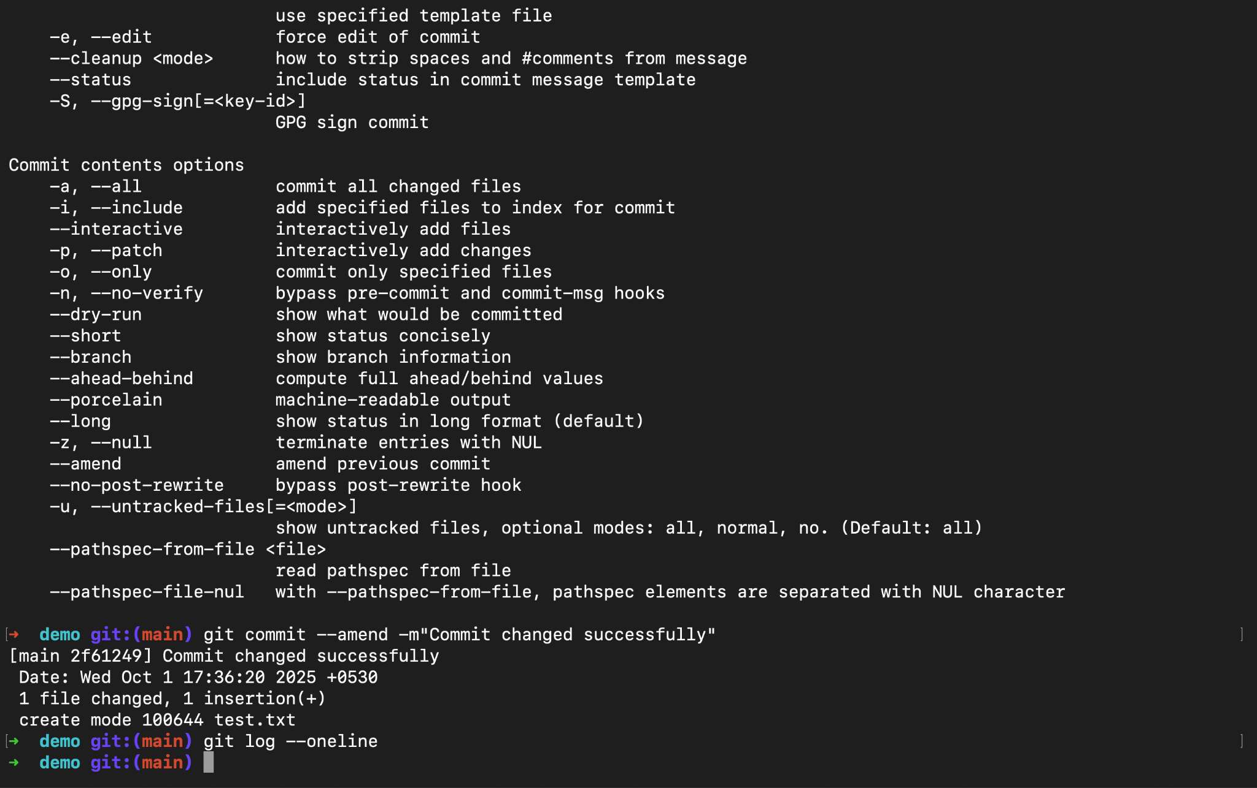

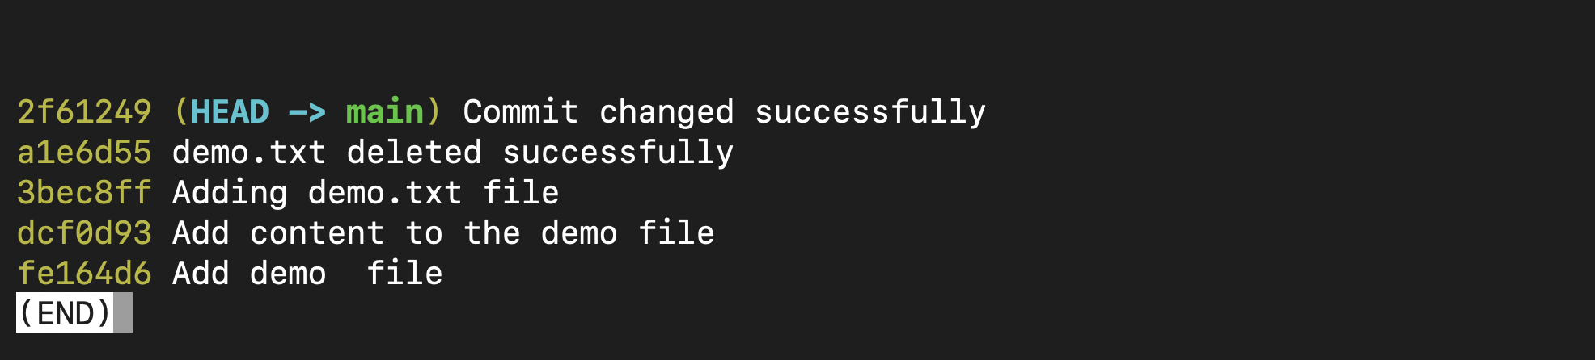

**Query: How does git reset differ from git rm ?**

* **git reset**

1. git reset is primarily used to undo changes, modify the commit history, or unstage changes.
2. To undo local commits you haven’t pushed yet.
3. To unstage specific files.

* **git rm**

1. git rm is used to remove files from the Git repository.
2. By default, git rm removes the file from both the staging area (index) and the working directory.
3. **Advanced Operations**

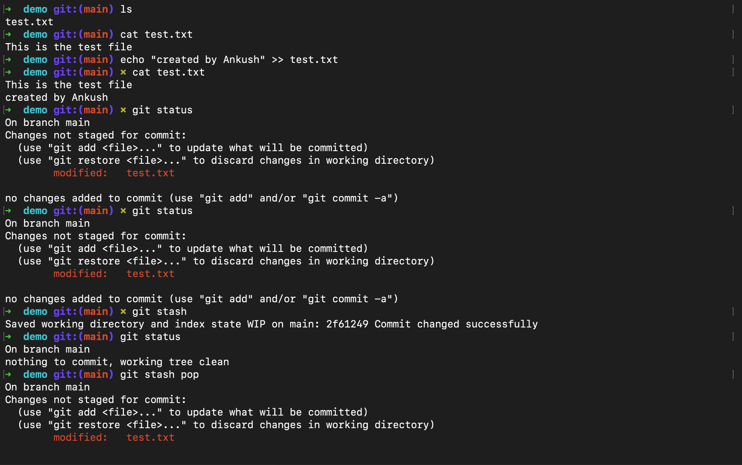

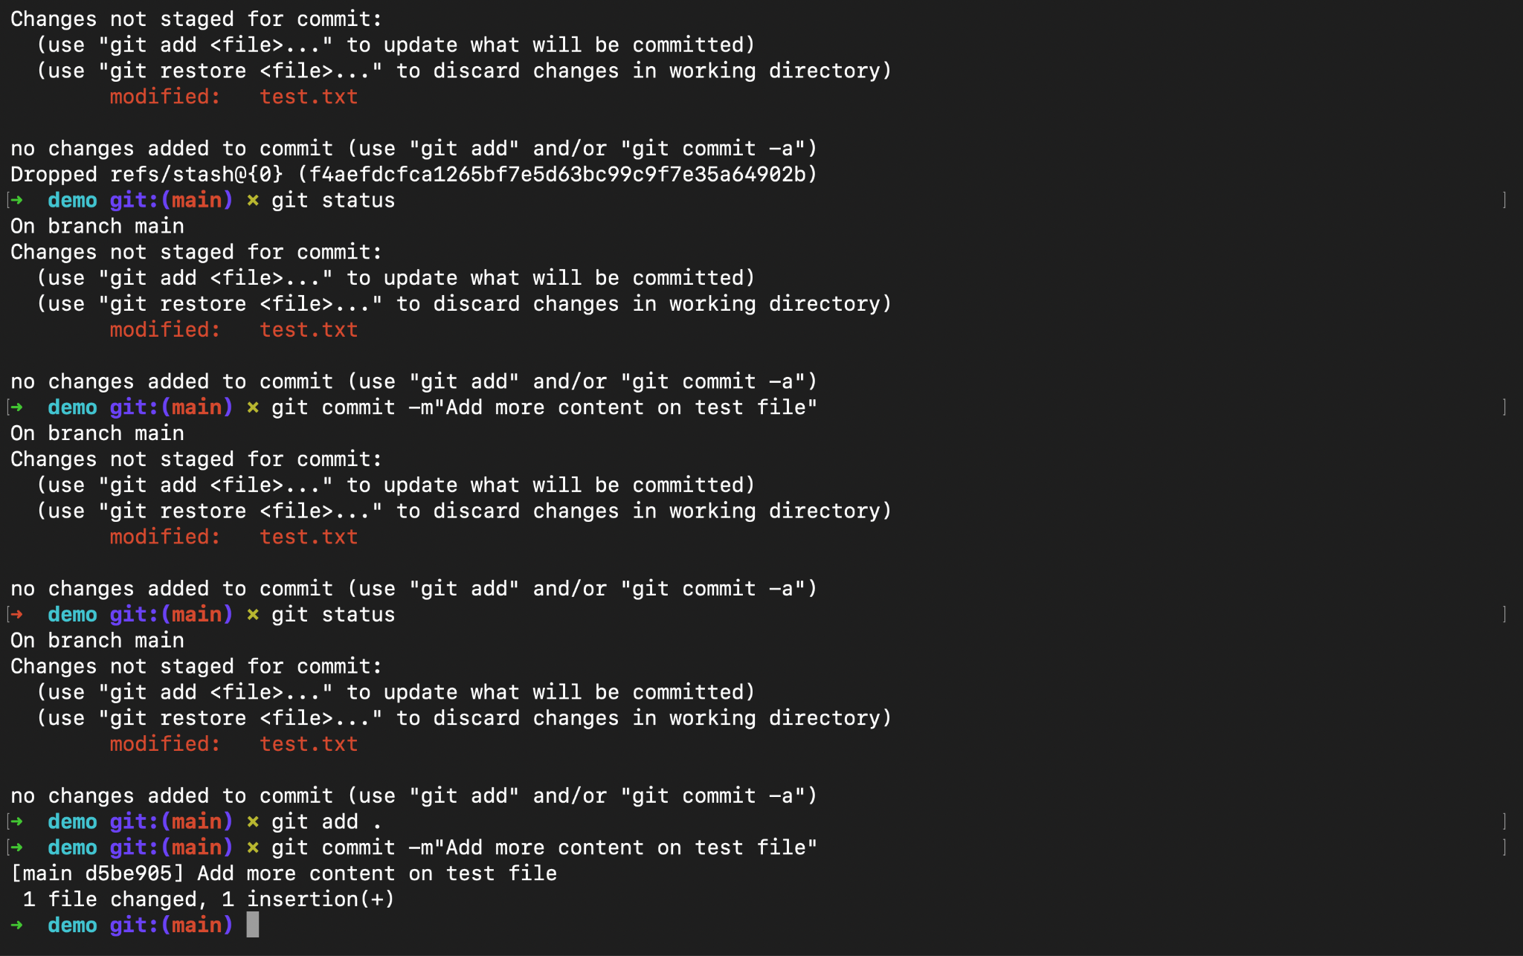

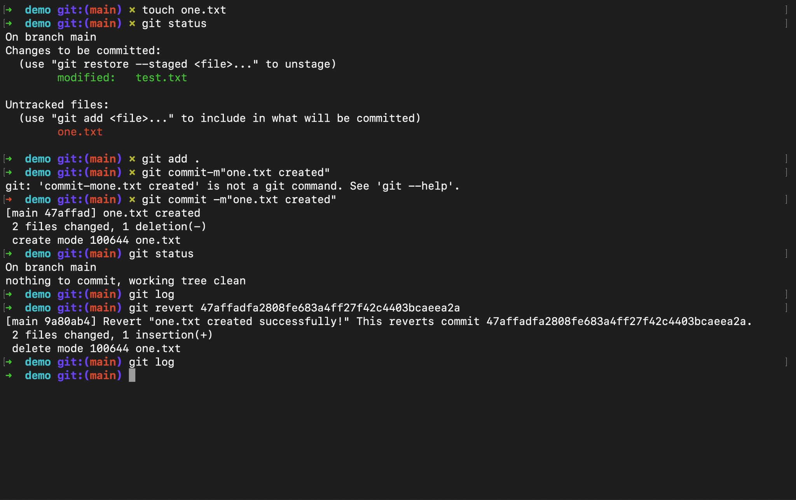

**Query: How does Git calculate file differences when using commands like git diff? (Hint: HEAD)**

=>git diff works , like it compares the screenshot , it stores complete file , snapshots as blob , and when hashes differ , it uses myers diffing algorithm to show difference